Yearly Airline Performance Report – 2019

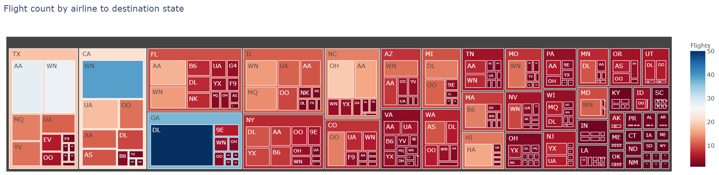

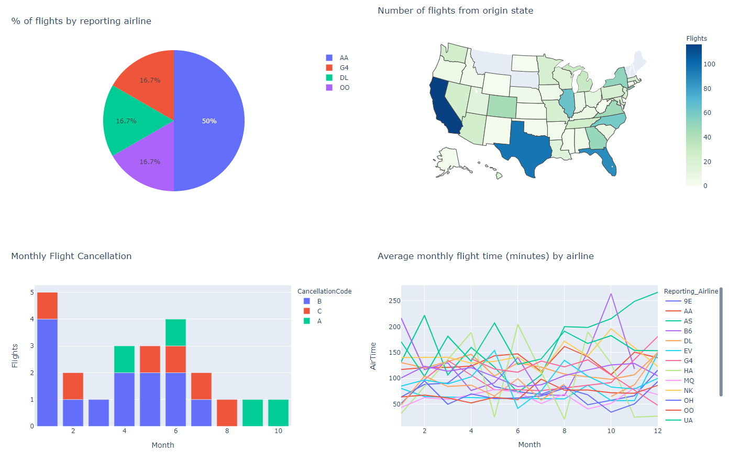

Yearly Airline Performance Report – 2015

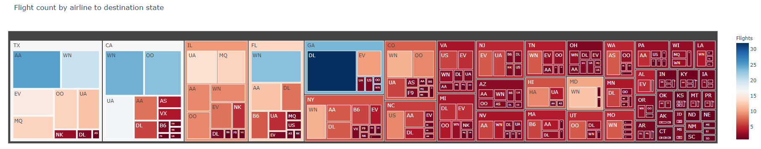

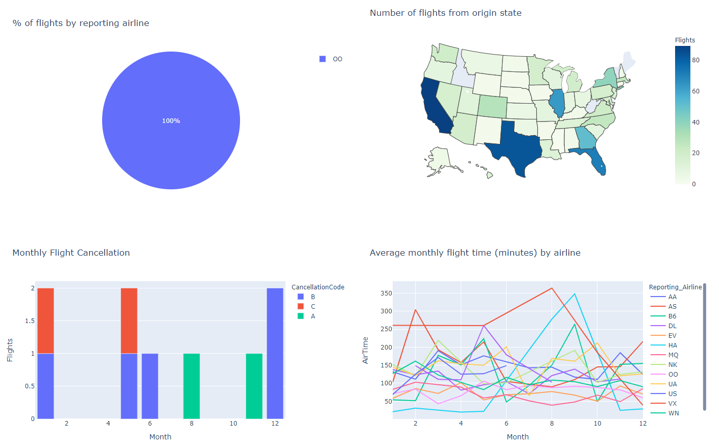

Yearly Airline Delay Report – 2019

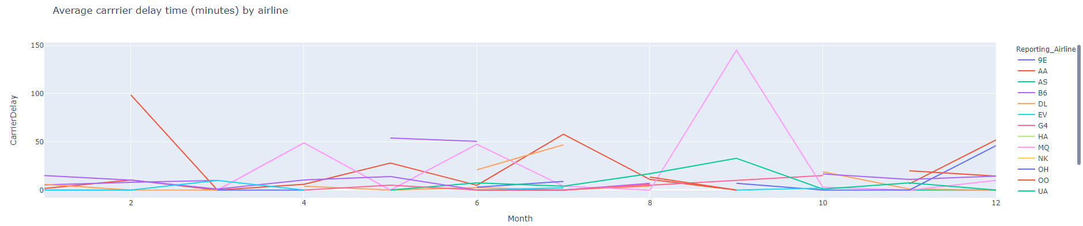

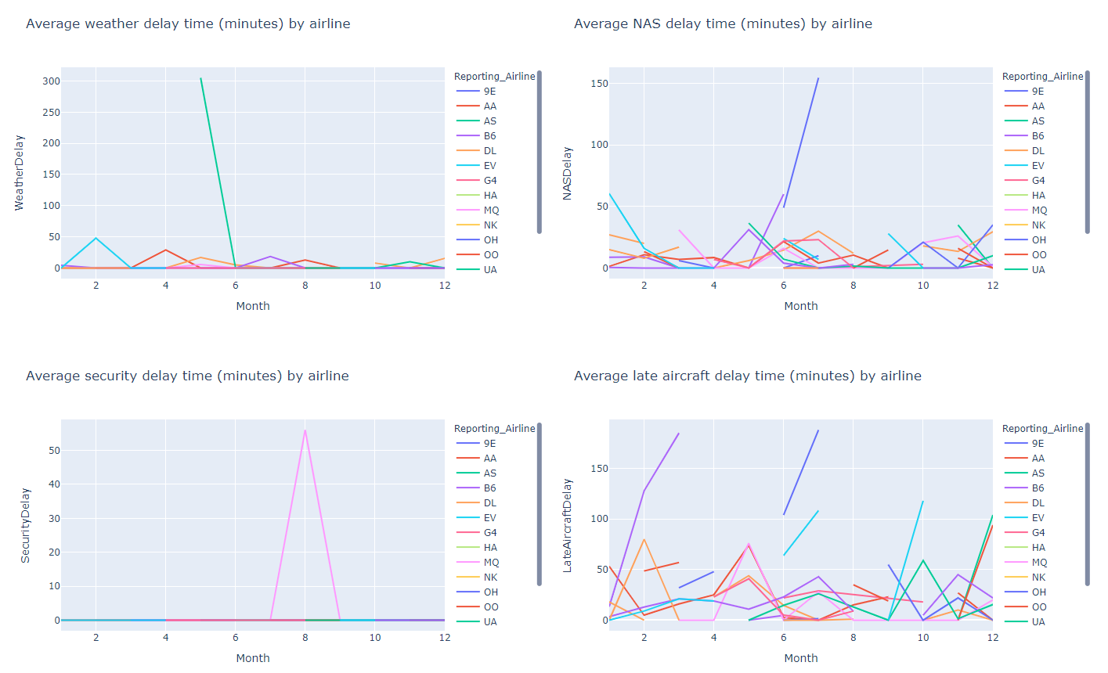

Yearly Airline Delay Report – 2008

